Medicines that affect the immune system
Medicines that affect the immune system are called immunomodulators. These drugs are divided into two groups according to the effects of stimulation (stimulation) and suppression (suppression) of the immune system:
1) Immunoactivators (activators)
2) Immunosuppressants (sedatives)
Immunoactivator
Chinese medicine has long established that the human body's resistance to febrile diseases increases after epidemics. The reason for this is the increase in resistance to those microbes in organisms that interact with microbes. For the first time in 1976. The vaccine against the smallpox virus discovered by Jenner, the bacterial vaccines discovered by Pasteur in 1881, and the resulting immunoplasmas laid the foundation for immunotherapy.
The immune system and the elements that make up this system are described in the figure below. The interactions between these elements are explained as follows: Lymphocytes and macrophages are the main cells forming the immune system. They affect each other in different combinations (effector = factor and mediator).
The main components of the immune system and their interaction with each other are based on the relationship between the macrophage-B-lymphocyte and the T-lymphocyte, as shown in the diagram below.
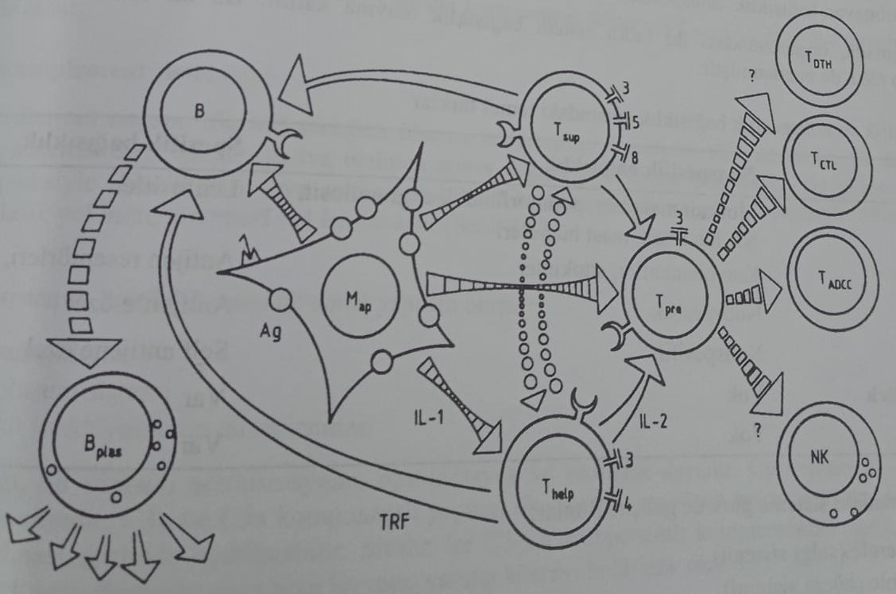
B- and T-lymphocytes, which can be distinguished from each other by functional or immunocytological and morphological methods, are divided into subgroups such as Thelp = helper lymphocyte or Tsup = suppressive lymphocyte, which participate in the repeated immune response. B-cells and B-cells of plasma can participate in the immune response and produce antibodies in the body. For this, macrophage precursor cells join the process together with Tpre cells. Associated immune reactions include hypersensitivity (TDH), cytotoxicity (TCTL) or lymphotoxicity of antibodies. At the same time, it was established that the natural cytotoxicity of T-cells comes from T-cells.
Both B-cells and T-cells have receptors on the surface of the membrane. Antigen binding to these surface receptors leads to the formation of an immune response. Antigens are transformed by the body into structures that can be attached to lymphocytes with the help of macrophages. These macrophages are called macrophages that produce Map=antigen. B-lymphocytes play an important role in the interaction of T-lymphocytes and macrophages with antigen. For example: they stimulate T-lymphocytes with interleukin-1 (IL-1), secreted by macrophages. This process also activates Tpre cells, producing interleukin-2. At the same time, B-lymphocytes are also activated by T-cell transformation factor (TRF). These regulatory compounds also regulate the interaction between macrophages and Tsup cells, B-lymphocytes and Tpre cells. This center is integrated with the immune response regulation system, the antigen-antibody complex and the complement system.
The complement system is activated by antibodies or other alternative factors as a result of antigen binding. There are other systems that directly or indirectly interact with the immune system. These include the blood coagulation system and the Hageman-kallikrein-kinin system. In addition to these systems, the immune system can be affected by various granulocytes. For example: neutrophils participate in immune complex reactions. Basophils are involved in allergic reactions.
The basis of immunity
The body's production of antibodies against a foreign body or microbe is called immunity. In other words, the body's resistance to microbes is called immunity. The mechanism of formation of antiism is carried out by two systems.
1) Specific immunity
2) Non-specific immunity
The main differences between these two systems are indicated in the table below.
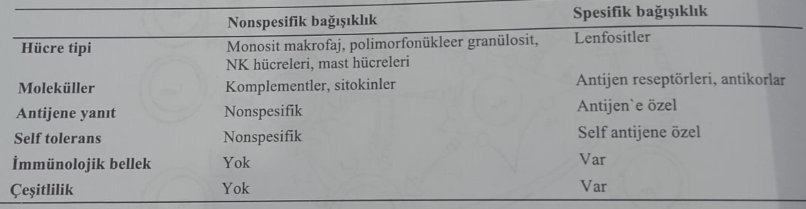
Immunity is regulated by the humoral (hormonal) system and the cellular (cellular) system. Humoral and cellular immunity are presented in the table below.
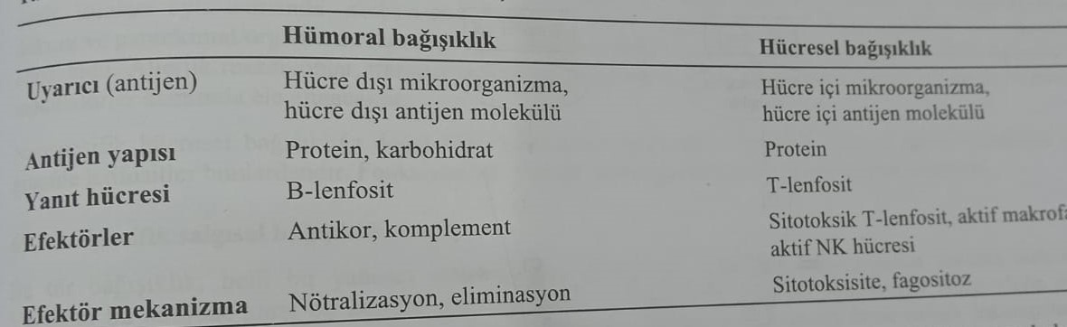
With a non-specific mechanism, the antigen does not come into contact with the body in advance, so specific antibodies are not detected against it. In the mechanism of specific immunity, the interaction of the antigen with the body is expected in advance, and as a result of this effect, a specific antibody is formed in the body.
Nonspecific humoral immunity
The systems involved in non-specific humoral immunity are as follows.
1) Systems of complements
2) Lysozyme
3) Interferons
4) Acute phase protein systems
These four systems are integrated with each other. For example: complement factors C3 and C4 act as proteins of the acute phase.

Add-on systems
Plasma factors are involved in the formation of non-specific immunity of the body. In particular, these factors are related to the complement system. They consist of 15 different proteins that can be activated. These glycoproteins are activated by the antigen-antibody complex (classical) or the external structure of some microorganisms without antibodies (alternative pathway). The classic way is fast, and the alternative way is slower.
The biological basis of the complement system is made up of three mechanisms.
1) Insensitivity to warning
2) Inflammatory system
3) Regulation of the function of B-lymphocytes
Vigilant immunity is based on neutralization, opsonization and cytolysis of the virus. Opsonization is called phagocytosis, which occurs under the influence of an opson. Phagocytosis of macrophages, occurring with the formation of structural components С3а and С5а, leads to the proliferation of the corresponding cellular receptors. Cytolysis is the death of cells caused by irreversible damage to membranes as a result of the reaction of complement components C5-C9 in cells that bind antibodies.
Components C3a and C5a (classical anaphylatoxin) are especially involved in inflammation. An increase in vascular permeability is observed as a result of the release of histamine from mast cells and basophilic granulocytes. And C3a causes the release of serotonin from platelets. Dilation of blood vessels, increased permeability of blood vessels and formation of edema occur due to the formation of lysosomal enzymes and derivatives of arachidonic acid from granulocytes. At the same time, it was established that the direct effect of peptides occurs on the vessel wall. C3b participates in the regulation of the formation of B-lymphocytes and antigen recognition.
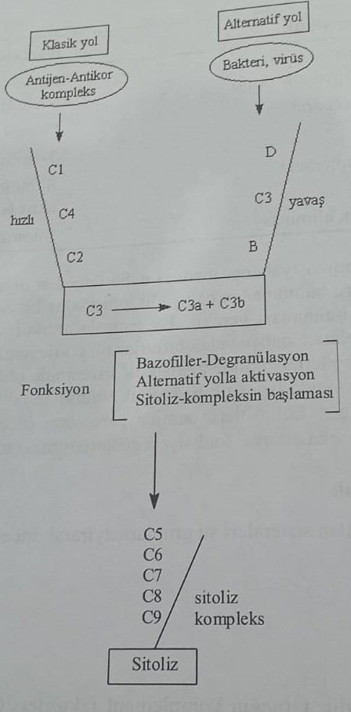
Lysozyme
Lysozyme, an important factor in nonspecific humoral immunity, is released as a result of fragmentation of phagocytized cells. It provides hydrolytic destruction of the cell walls of gram (+) bacteria, such as staphylococci and streptococci.
interferon
Interferon, which plays an important role in immunity during viral reactions, will be considered in more detail.
Acute phase proteins
Deformations of tissues lead to the formation of acute phase proteins. They are also called anti-inflammatory proteins. For example, C-reactive peptides split lipids of lysed cells or act as alpha-antitrypsin, proteinase inhibitors. Acute phase proteins include some blood coagulation factors, components of the complement system C3 and C4 or carrier proteins such as heptaglobulin and seraplasmin.
Non-specific cellular immunity
Phagocytes: amoeboid cells belonging to leukocytes. Basically, they have phagocytic properties. These cells are divided into 3 groups.
1) neutrophilic granulocytes
2) Eosinophilic granulocytes
3) Monocytes
The first two of them are called macrophages. Blood cells with very strong phagocytic activity are called monocytes. These cells are also called free macrophages. Stabilized macrophages are mainly found in blood vessels, connective tissue and parenchymatous tissues (liver tissue). The main function of macrophages in the immune system is phagocytosis.
Non-specific cellular immunity includes natural killer cells. This group includes granular lymphocytes that kill viruses and, in particular, tumor cells. Its function is to increase the synthesis of interferon in cells.
Specific humoral immunity
Specific humoral immunity is a protective mechanism of the body against a certain foreign substance (antigen). The body produces an antibody, which is a protective substance against this antigen. Lymphocytes play a major role in the formation of antibodies. They produce immunologically incompetent cells from bone marrow stem cells. They are called B-lymphocytes.
Antigens: All foreign substances entering the body are named. Against the antigen, the body initiates an immunological reaction both in the blood and in other tissues. The substance required for the reaction is called an antibody, and the product resulting from the reaction is called an antigen-antibody complex. Large proteins, carbohydrates, and nucleic acid polymers with a molecular weight of more than 3000 kDa are considered antigens. These substances have certain serological characteristics. These properties determine the binding state of the antibody to the molecule. Small molecules bind to certain proteins in the body and become antigenic. These compounds are mostly covalently linked and are called haptens. Some antigens activate both humoral and cellular immunity. This activation occurs with the participation of macrophages. Without the participation of a macrophage, a substance with direct antigenic properties can cause the synthesis of antibodies in very small quantities.
Antibodies: mainly produced by plasma cells under the influence of B-lymphocytes. They exhibit different properties depending on the antigen. They form an antigen-antibody complex, which follows the key-lock principle, similar to the drug-receptor complex. Such antibodies are called immunoglobulins. Among them, gamma globulins are of the greatest importance.
Antibodies are produced in plasma cells. They are synthesized from plasma cells with the help of preantibodies transmitted from B-lymphocytes under the influence of an antigen. The most important mechanism here is the formation of B-recognizing lymphocytes from B-cells. These cells store antigenic information for a long time. Antibodies are produced when this antigen is encountered again. For example, one plasma cell produces 2000 antibodies per second. The cells that act as a bridge between macrophages and B-lymphocytes are T-lymphocytes. At least 106 different determinants and 106 lymphocytotoxins have been found in the human body. In fact, they are present in the body from the first moments of life. Upon introduction of the antigen, each of these ready-made clones multiplies.
Monoclonal antibodies: if an antigen contains many determinants, many antibodies can be formed physiologically against it. Thus, a clone can be formed from plasma cells. Such substances are called monoclonal antibodies.
The formation of such monoclonal antibodies occurs as a result of the interaction of the tumor cell with B-lymphocytes. The resulting cell is called a Zwitter cell (hybrid cell). These cells have the ability to produce antibodies from B-lymphocytes. These cells are used for diagnostic purposes (blood typing, diagnosis of tumor cells). They are used in organ transplantation and cancer treatment.
The antibodies are called immunoglobulins (Ig). These substances can be separated and grouped using electrophoresis. Immunoglobulins are divided into 5 groups: IgG, IgM, IgA, IgD, IgE.
Immunoglobulin contains two heavy (H) and two light (L) chains. This chain is linked together by disulfide bonds and has a Y-shape as shown in the figure. In particular, the branched portion where the L- and H-chains are joined is the terminal amino group forming the antigen-binding region. This part is called FAB (Fragment Antigen Bound). The area where two H-chains join is the crystalline part of the globulin and is called FC (Fragment Crystalli). This site provides circulation of immunoglobulins in plasma, as well as diffusion from the placenta and complement activation.
As can be seen from the table, the most rapidly formed immunoglobulin is IgM. Both parts of the immunoglobulin can be dimeric, tetrameric, pentameric. These structures exhibit diversity in antigen binding. For example, IgM has a pentameric structure and can combine 10 antigens at the same time. IgG is the lightest immunoglobulin and therefore easily crosses the placenta. It protects the baby from infections in the first two months. IgA is found in breast milk. After IgG, it is the most common immunoglobulin. It is very effective against viruses. In particular, it protects the cell membrane from viruses and bacteria. Information regarding IgD has only recently appeared. It is thought to regulate responses during lymphocyte differentiation.
The physiological role of immunoglobulin E is still unknown. However, pazarite has been found to play an important role in immunity. The binding site of the FC-part of IgE2 (cytophilic antibody) is located in the membrane receptors of immune cells and basophilic granulocytes. Part of the FAB binds to related antigens and causes allergic reactions.
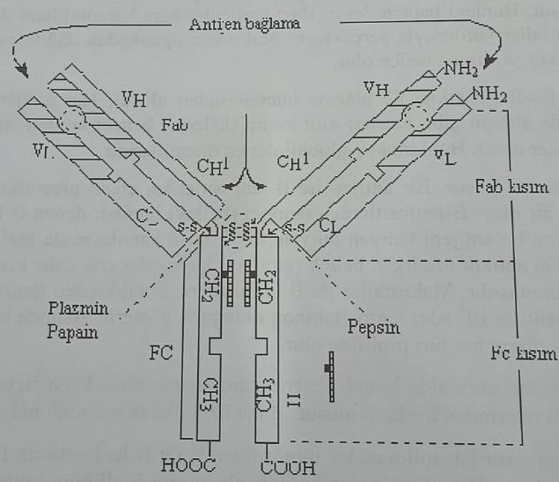
Antigen-antibody reactions
The antibody reacts with the determinant (points of contact) on the surface of the antigen. The antibody undergoes some conformational changes. Basically it happens in FC district. Antibody interacts with complement factors. The binding of the antigen to the active part of the antibody is called neutralization. These reactions include precipitation, agglutination and cytolysis. If the antigen is in dissolved form, the reaction is manifested by precipitation. Large antigens, such as erythrocytes, enter the agglutination reaction. When the specific antibody-complement interaction and activation of the complement system increases, cell permeability increases and lysis occurs. Antigen-antibody reactions lead to opsonization and immobilization.
Specific cellular immunity
T-lymphocytes: a group of secondary lymphocytes originating from the stem cells of the bone marrow. It carries immunological reactions in the thymus, where it produces cells with immunological properties. These cells, which are activated by the thymus gland, are called T-lymphocytes and perform a connecting function between the lymph nodes and the protective tissue Mils. T-lymphocytes provide immunity. They form semi-specific receptors on the surface of cells. These receptors recognize antigens and have the ability to bind to antigens. The production of antibodies shows whether the body is responding to cellular immunity. As in B-lymphocytes, the target clone in T-lymphocytes proliferates upon first contact with the antigen. In the presence of macrophages, an increase in clonal proliferation of T-cells in the presence of antigens is observed. Some of the newly processed cells form recognizing lymphocytes. They are similar to the cells that recognize B-lymphocytes. They cause violent immunological reactions upon contact with a recurring antigen.

Immunization (immunity)
The resistance of the organism to an irritant without a pathological reaction is called immunity. Immunity to many infectious diseases occurs at the first contact. Sometimes immunity can be preserved for life. But immunity is provided artificially in two ways.
1) Active immunization: it is provided by introducing a harmless antigen into the body.
2) Passive immunization: it is provided by the introduction of antibodies into the body.
Active immunization (vaccination)
In this very widely used method, the production of antibodies by the body is ensured by applying a vaccine containing a harmless antigen to the body. The main condition of active vaccination is the presence of an antigen vaccine administered in a certain concentration. If a vaccine containing more than the indicated concentration of antigen is used, the infection in the body is aggravated.
Vaccination is carried out in two ways:
1) Scheduled vaccination
2) Vaccination according to indications
Planned vaccination is mainly carried out by public health authorities against problematic infections. Examination is carried out according to the principle of national vaccination. At the same time, these vaccines are used according to a certain vaccination schedule. Some of them are vaccines administered at birth.
1) 3 months: Diphtheria, tetanus, poliomyelitis, whooping cough, measles and others.
2) 15 months: Cory
3) 2 years: Diphtheria, tetanus, poliomyelitis
4) 7 years of diphtheria
5) 10 years: poliomyelitis
6) 15-16 years: measles
Types of vaccines: According to the type of antigen used, vaccines are divided into 3 groups:
1) Vaccination with non-pathogenic and non-virulent microorganisms (live vaccination)
2) Vaccination with inactive virus and dead bacteria (dead vaccination)
3) Vaccination with toxoid vaccines (diluted vaccines)
Pharmaceutical forms of these vaccines are divided into 2 groups:
1) Liquid vaccines: vaccines prepared and ready for injection.
2) Absorbent vaccines (dry vaccines): in such vaccines, the antigen is absorbed by aluminum hydroxide gel. In the process of application, it is diluted with physiological solution and prepared for injections.
Standard vaccination
Diphtheria vaccine: this is an active vaccine. Diphtheria-formol-anatoxin is absorbed by aluminum hydroxide. Very pure antigen is used. 50-70 TVs are inoculated three times. It can be repeated every 8 years in a dose of 5 TV. Allergic reactions are very rarely observed, for example: skin rash, redness, swelling, etc.
Vaccine against tetanus: obtained from the toxin of Clostridium tetani, spore-forming anaerobic bacteria. Tetanus is a very deadly infection, but immunity can be induced with active immunization. Bacteria are inactivated by keeping Clostridium tetani culture in formaldehyde. The vaccine is prepared by absorbing the obtained toxin with aluminum hydroxide gel. Thus, it is obtained tetanus-formol-anatoxin. The vaccine is administered in 0.5 ml intramuscularly (intramuscularly) twice with an interval of 4-8 weeks. After 6-12 months, the third vaccination is given. After 10 years, if many lesions are observed, vaccination is recommended every 5 years.
Vaccine against poliomyelitis: Poliomyelitis, also known as poliomyelitis, is caused by 3 types of the poliomyelitis virus. This wool provides absolute protection against diseases. All three types are obtained by inactivating the virus. It is administered with an interval of one month. The third vaccination is done after a year. At the same time, the advantage of this vaccine is that it is suitable for oral administration. It is applied with an interval of 6-8 weeks and is checked every 10 years.
Measles vaccine: Measles is a viral infection that causes encephalitis and secondary bacterial infections. Live vaccine Mazern is administered subcutaneously.
Vaccine against epidemic mumps: This vaccine is used to prevent meningitis, pancreatitis and other secondary diseases. It is applied subcutaneously.
Rubella vaccine: although rubella is a rare disease, it occurs in children and adults. Vaccination plays an important role in disease prevention. Because if the mother is infected with the virus in the first month of pregnancy, the embryo is infected with the virus directly. Deafness, blindness and heart defects are observed in children born later. Therefore, the use of this vaccine, especially before pregnancy, is the main condition. They get a virus.

Indications for vaccination
BCG (tuberculosis) vaccine: used for the prevention of tuberculosis. The bull type of non-pathogenic tubercle bacilli is used to prevent infection of newborns. Before introducing BCG (Bacilla Calmette-Guérin) to elderly people, it is important to conduct tuberculin testing (ppd).
Hepatitis-A vaccine: Hepatitis-A, which is transmitted through contaminated food products and household items (scalpers, scissors, needles, etc.), is especially widespread in industrially developed countries. The vaccine is obtained from cultured cells and has 5-10 protective properties. For this, a second vaccination is carried out after 1 month, and the third after 6-12 months.
Vaccine against meningoencephalitis at an early stage: an ectoparasitic tick-borne viral disease that is often found in people living near streams in southern Europe. After the first vaccination, the second one is done after 1-3 months, and the third one after 9-12 months. A repeat application is recommended after three years.
Flu vaccine: successful flu vaccination inactivates the flu virus. 0.5 ml is injected intramuscularly. Adults are at high risk of getting the flu, despite vaccination.
Vaccine against rabies: Rabies virus, cold-resistant, with a long period of inactivation, belongs to the group of RNA viruses, found in all warm-blooded animals. Neurotropic disease with such symptoms as sensitivity to light and heat. As a result of scratching and biting, the virus enters the blood. These persons are injected with 1 ml of vaccine 2 or 3 times. Vaccination is carried out 5 times for 3, 7, 14, 30 and 90 days. If the infected virus is in the incubation period and entered the body due to trauma around the brain, treatment with additional hyperimmune globulins is started during vaccination. Thus, full protection is ensured.
Vaccine against smallpox. In 1979, WHO reported that smallpox, which was once a serious problem, is practically non-transmissible worldwide. For this reason, mandatory vaccination has been canceled in some countries.
Vaccines for travel: vaccination against various infections is considered necessary when traveling abroad in North America and Europe. The following applies to this:
1) Certain vaccinations for travel
2) General recommended vaccination
3) Special vaccination program
This vaccination is used to protect the health of not only the traveler, but also people living at the destination.
Passive immunization
Unlike the active vaccination mentioned so far, antigen synthesis is induced in the blood of some animals, such as horses, sheep, cattle and dogs. Then antibodies obtained from the blood of animals are injected into people and create passive immunity. These preparations are called serum. When preparing these preparations, antibodies are used not only from animals, but also from sick people. Basically, the protective period of these preparations varies between 8-14 days. With a serious infection, the incubation period is insufficient for the production of specific antibodies and in the absence of a suitable chemotherapeutic agent against infection, the method of passive immunization is used.
Animal plasma
Horses, goats and some other large animals are used to obtain plasma. For this, the antigen is injected into the animal for a long time. This process continues until the period when the antibody reaches its highest concentration in the animal's blood. Then they take blood from the animal and separate the plasma from the blood to obtain natural plasma. Such plasma cannot be administered directly to people. Because plasma diseases can occur, such as fever, swelling and swelling of lymph nodes. At the same time, anaphylactic shock may occur. The purification method is used to separate unpurified plasma from foreign proteins. Globulin is split by fermentation to obtain pure plasma. The table below shows some of the plasma obtained.
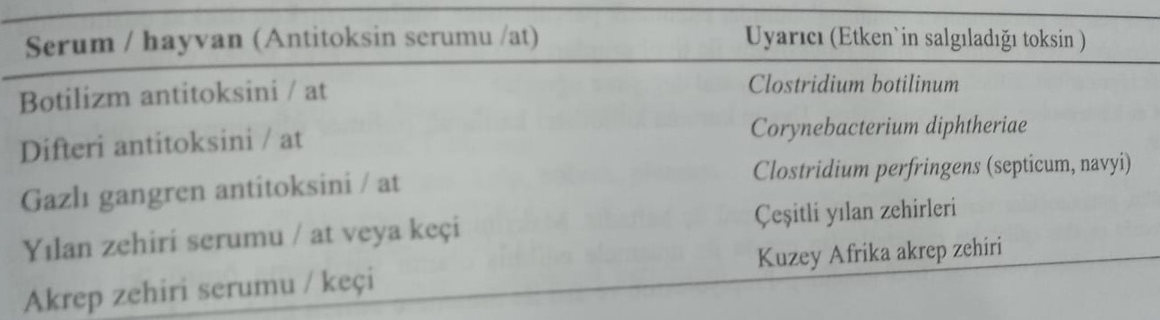
Human immunoglobulin
Human immunoglobulins are present in the blood plasma of recovered people instead of the plasma of animals. Preparations of immunoglobulins are divided into two groups.
1) Non-specific (polyvalent) preparations of immunoglobulins (a mixture of different antibodies)
2) Specific preparations of immunoglobulins
Preparations of non-specific immunoglobulin
Intramuscular and intravenous injections are divided into two groups. These preparations are obtained from blood fractions obtained from at least 1000 different people. The main risk factor is blood obtained from carriers of HbsAg (hepatitis) and HIV infection. For this, according to blood donors, the following safety measures must be taken:
1) Selection of suitable persons for blood donation
2) Immunoglobulin production method
3) Screening of risk factors such as hepatitis and HIV in plasma
As a result of fractionation, any immunoglobulin with a purity of 95% is obtained. Preparations of non-specific immunoglobulins and indications for use are shown in the table below.
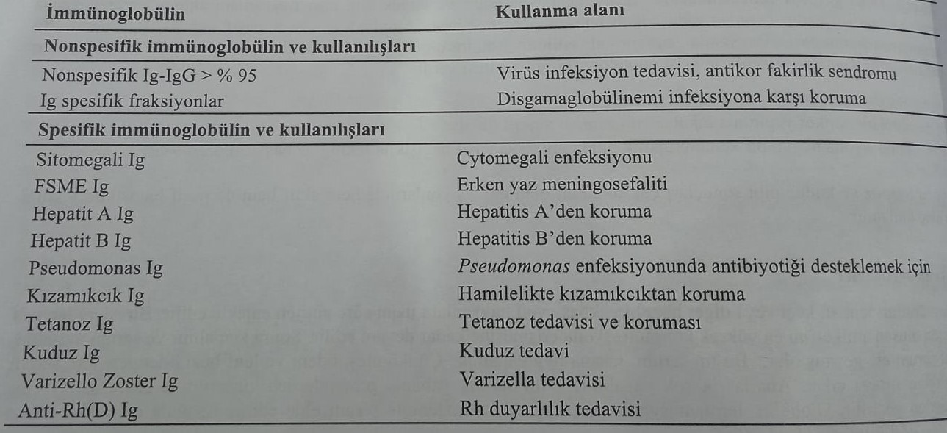
Intravenous immunoglobulins are used for patients in special conditions. These special measures are listed below:
1) Immunoglobulins are enzymatically cleaved by such enzymes as pepsin and plasmin. This feature should be taken into account when finishing.
2) thiol groups are irreversibly blocked by the restoration of β-propionolactone or disulfide bonds.
3) undergo reversible chemical transformation by sulfitolization of disulfide bridges.
4) possible degradation ph=4. It is necessary to prevent polymerization by introducing appropriate colloids into the solution.
With intramuscular administration of immunoglobulins, the half-life period is 3 weeks. The maximum immune titer is reached in 3-5 days. The elimination period of intravenous preparations (with pepsin) is two days. The half-life period of plasmin preparations is 10-20 days. The elimination period of β-propionlacton preparations is 2-7 weeks.
Classification of immunomodulators (Classification)
When they call the immunomodulating effect, they understand that the speed of immunological reactions increases (stimulating effect) or decreases (inhibiting effect). Just as immunomodulators enter the body from the outside, so do autonomous immunomediators from the inside. In addition to vaccines and plasma, immunomodulators used in the clinic include:
1) Cytokines: they are naturally present in the body. These are endogenous immunomodulators.
2) Exogenous immunomodulators: inosiplex, extract of Echiacea purpurnoy and bacterilysates.
Cytokines
Cytokines are regulatory proteins or glycoproteins synthesized by the corresponding cells of the body. Molecular masses vary from 10 to 65 kDa. Cytokines are synthesized in the most different cells and act on the most different cells. Functionally, they are divided into the following groups:
1) Factors affecting cell movement: they act as chemotaxic factors (inhibition of migration).
2) Factors affecting the proliferation and differentiation of cells: formation of interleukin-1,-2,-3,-B-cells, differentiation factors, T-helpers, suppressor factors, colony-stimulating factors and macrophage-stimulating factors.
3) Affecting the viability of target cells: Lymphatoxin, interferon, tumor necrosis factor.
Cytokines show their effects by binding to specific receptors on cells. These are paracrine, autocrine and endocrine receptors. Biosynthesis and secretion of cytokines occurs with the participation of endogenous factors or other types of cytokines. For example: cytokines stimulated by lymphocytes are called lymphokines.
The most important immunomodulating cytokines are:
1) Interleukins (IL)
2) Interferons (IFN)
3) Tumor necrosis factor (TNF)
4) Transforming growth factor (TGF-β)
5) Colon stimulating factor (CSF)
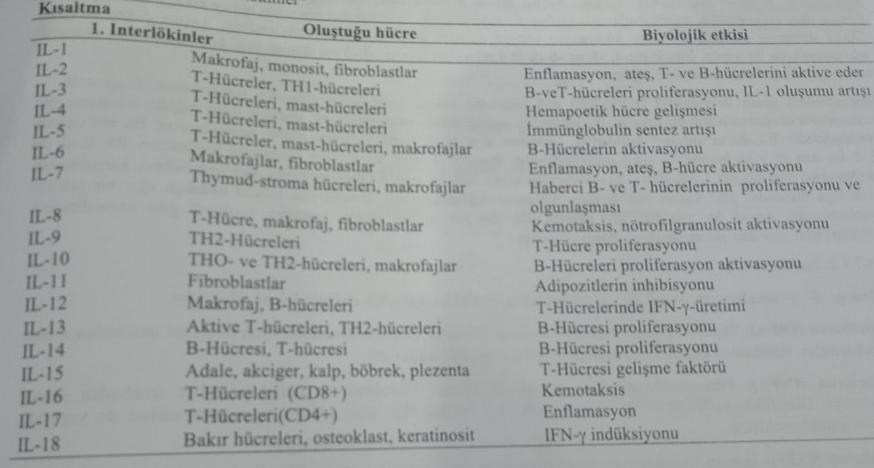
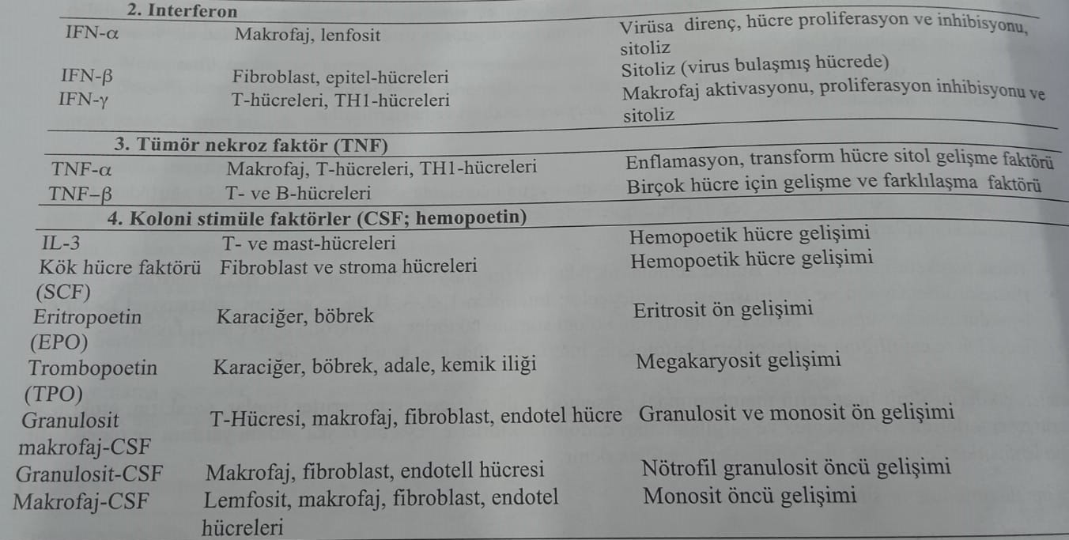
Interleukins
In the literature, interleukins are denoted by the abbreviation (IL). 18 different types of interleukins are known to science. Basically, they are synthesized by macrophages and T-cells and act on lymphocytes.
Synthesized in macrophages, interleukin-1 (IL-1) ensures the proliferation of T- and B-lymphocytes. При их частии, the secretion of interleukin-2, -4 and -6 increases. At the same time, the secretion of the colonic factor increases. Interleukin-1 is an endogenous pyretic substance that mainly acts as a mediator of inflammatory processes. Activating T-helpers, increases the synthesis of interleukin-2. At the same time, it increases the synthesis of other lymphokines. Interleukins-4, -5 and -6 activate B-lymphocytes. Interleukin-3 activates the stem cells of the bone marrow and increases hematopoiesis.
Recombinant human interleukin-2 (proleukin) is obtained in glycosidized form. This substance stimulates the formation of cytotoxic T-lymphocytes. These lymphocytes affect both tumor and normal cells. Activated T-lymphocytes are known as lymphokine-activated killer cells. The activating effect of interleukin-2 was known as a result of studies both in vitro and in vivo. In in vitro studies, patients' lymphocytes were incubated with Rh-interleukin-2. LAK (Lymphokine Active Killer) cells obtained as a result of incubation were returned to the patient. Thus, a therapeutic effect was achieved in kidney cancer. However, side effects were manifested in very heavy pictures. These side effects include edema, hypotension, and tachycardia. Nausea and fever may be observed after long-term use.
Interferons
Basically it is divided into types α, β and γ. Its molecular weight is about 20,000.
1) α-interferon (INF-α): formerly called leukocytic interferon. It is synthesized by various cells of the lymphatic system. Today, 15 different types of α-interferon have been identified.
2) β-interferon (IFN-β): also known as interferon of fibroblasts. It is synthesized by fibroblasts and epithelial cells. Its concentration in the body increases mainly due to the action of the virus.
3) γ-interferon (IFN-γ): also called immune interferon. It is mainly synthesized in lymphocytes. The synthesis of IL-2 increases. This process is caused by the action of any antigen.
In particular, INF-α and INF-β are antiviral and proliferative. INF-γ has both antiviral and immunomodulatory effects. INF-α and INF-β are called interferons of type 1, and INF-γ are called interferons of type 2.
Interferons show their antiviral effect by reducing the synthesis of viral protein. They cause the breakdown of nucleic acids. Synthesis of interferon increases in the cell, where the virus penetrates, and the produced interferon is removed from the cell. This interferon binds to receptors on the cell membrane and forms a protein kinase in the ribosome, which is necessary for the synthesis of n-RNA, and inhibits viral translation by activating the initiation factor. At the same time, 2,,5,-oligoadenylate stimulates synthetase and causes nuclease activation. This enzyme causes cleavage of ribosomal n-RNA and m-RNA. Thus, it prevents the virus from spreading to healthy cells.
It has an immunomodulating effect due to the activation of natural T-cells-killers. Type 1 interferons provide the formation of HLA molecules. They do this by activating macrophages. Thanks to this, foreign cells are better recognized by the immune system. Protein-based interferons are administered parenterally and intranasally. The half-life period of INF-α and INF-β is 2–4 hours, and INF-γ is 30 minutes.
ИНФ-α is used topically in the treatment of herpes keratitis. At the same time, it is used for leukemia, chronic myeloid leukemia and T-cell lymphoma. It is also used for the treatment of chronic hepatitis B and hepatitis C.
ИНФ-β is used in patients with viral encephalitis and immunodeficiency. It is used locally in carcinomas of the nasopharynx and in the treatment of acute condylomas. INF-γ is used in the treatment of rheumatoid arthritis. Systemic administration of interferon causes flu-like symptoms and fever. The reason for the fever is an increase in the synthesis of IL-1 in macrophages. Side effects include dizziness, nausea, leukopenia and thrombocytopenia.
Tumor necrosis factor (TNF)
This is an effective factor in cell development. Two different types of TNF-α and TNF-β are known to science, depending on where they are produced. These substances are synthesized under the influence of interleukin-1. TNF inhibits the growth of tumor cells and has a cytotoxic effect. Endothelial system is damaged, especially kidneys and liver. It was clinically used to relieve flu-like side effects.
Colon stimulating factor (CSF)
This substance is a hematopoietic growth factor. Provides synthesis of erythropoietin, stimulating formation and activation of leukocytes and formation of erythrocytes. It is synthesized by monocytes, fibroblasts and endothelial cells. Granulocytic macrophage activation factor of the large intestine (GM-CSF) increases the formation of granulocytes and macrophages. This non-glycoside substance, obtained by a biotechnological method from the culture of E.coli, is used to limit leukopenia in the treatment of cytotoxic tumors. Side effects include bone pain, fever due to increased IL-1 production, and hypotension. Its use in myeloleukosis is contraindicated.
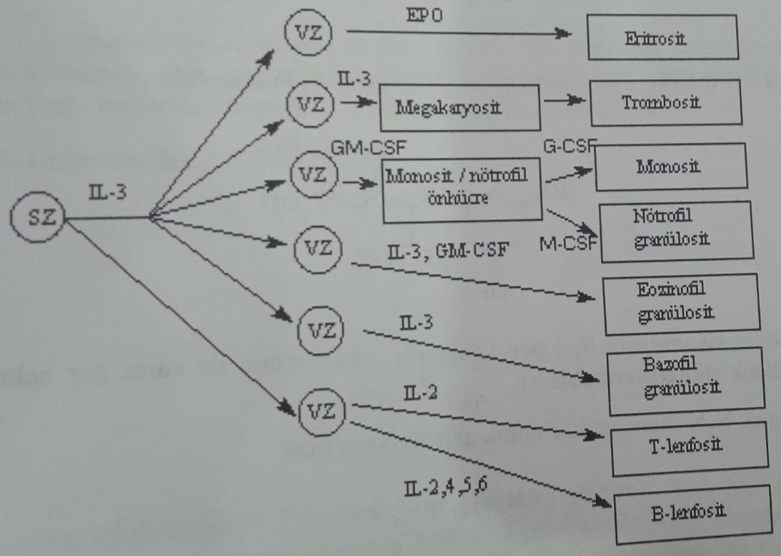
Exogenous modulators
This group includes inosiplex and extract of Echinacea purple, bacterilysates obtained from Escherichia coli together with cyanidanol and imutiol, and other immunomodulators used in viral infections of the urinary tract.
Inosiplex
Inosine is a complex dimepranol-4-acetamidobenzoate.
Along with its effectiveness against viral infections, Inosiplex is also used as an immunomodulating agent in the treatment of tumor diseases. It is especially used after surgery and radiation therapy. The preparation is obtained by mixing 1 mole of inosine with three moles of 1-dimethylamino-2-propanol 4-acetamidobenzoic acid salt. This complex is used as a medicine. Independent use does not show pharmacological activity.
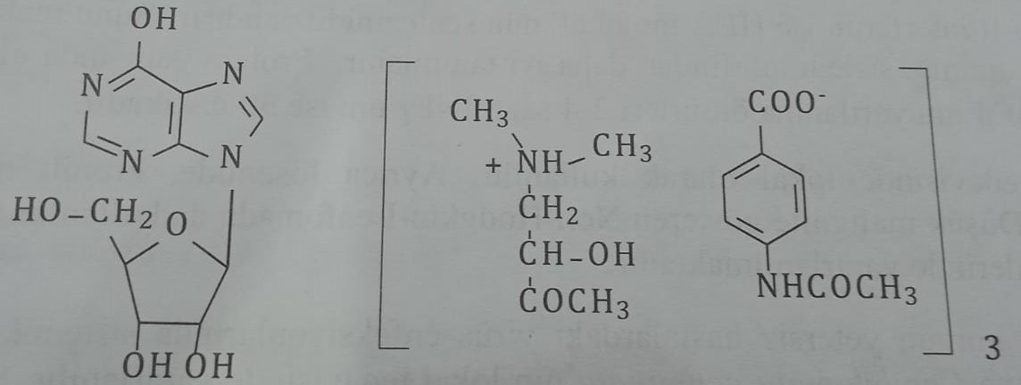
Echinacea purple extract
This extract contains a mixture of polysaccharides, lipophilic alkylamines and chicory acid (2,3-O-dicafferoyl tartrate). The immunomodulating effect is most likely caused by this mixture.
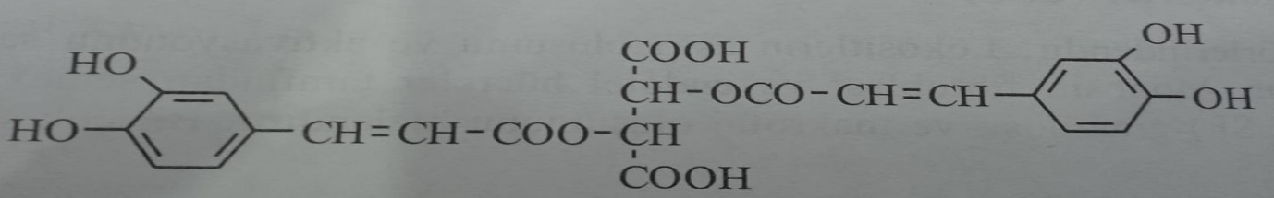
Cyanidanol
(+)-2-(3,4-Dihydroxyphenyl)-3,4-dihydro-2H-1-benzopyran-3,5,7-triol= (+)-Cathedrin
Cyanidanol, a dihydroflavanol derivative, is used as an immunomodulatory agent to prevent liver necrosis by inhibiting lipid peroxidation.
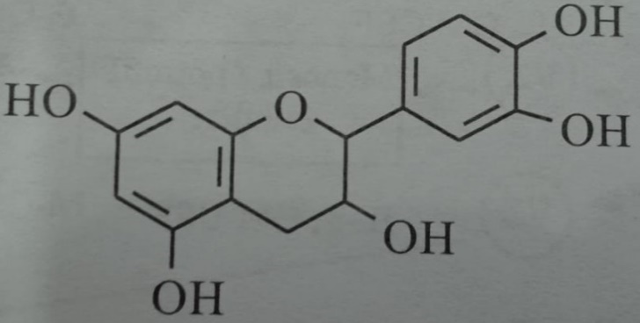
Imuthiol (Dithiocarb sodium): Sodium salt of N,N-diethylthiocarbamic acid
It is a non-toxic immunotherapeutic drug. It has an activating effect on T-lymphocytes. Activates NK (Natural Killer) cells without affecting interferon levels. It increases antibody synthesis by having an activating effect on B-lymphocytes. It specifically regulates helper and suppressor T lymphocyte levels.
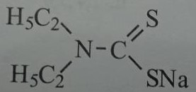
Levamisole: (-)-2,3,5,6-Tetrahydro-6-phenylimidazole[2,1-b]thiazole
Tetramizole, a racemate compound, has been used for many years as an anthelmintic. Levamisole is the l isomer of racemate and is used as an immunostimulant and antiallergic agent. It strengthens the immune system, especially after radiation therapy and chemotherapy.
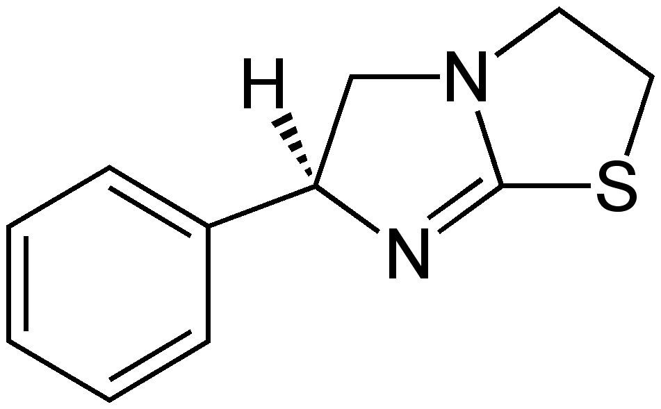
Immunosuppressant
Compounds known as immunosuppressants suppress immune reactions. They eliminate the body's immune response. In autoimmune diseases and organ transplantation, the presence of a negative influence of the immune response causes deterioration of the patient's condition. Some patients have an immune reaction to this substance, despite the fact that this substance is compatible with the body. Diseases arising as a result are called autoimmune diseases. Immunosuppressants are used in the treatment of these diseases.
The main groups of immunodepressants are as follows:
1) Glucocorticoids
2) Cytostatics
3) Cyclosporine
4) Antilymphocyte globulins
glucocorticoids
They suppress the proliferation of cells, preventing the secretion of interleukin-2 by T-lymphocytes.
Cytostatics
Cytostatics include cyclophosphamide, methotrexate and azotiaprine. The first two of them are anticancer. Azotiaprine is more widely used as a cytostatic.
Azothiaprine (Imuran): 6-[(1-methyl-4-nitroimidazol-5-yl)thio]purine
This is an inhibitor of the secretion of interleukin-2 (IL-2). It acts as a glucocorticoid. Side effects include leukopenia and thrombocytopenia. At the same time, decreased appetite, indigestion (dyspepsia), depression of the bone marrow, liver and kidney function disorders are observed. Do not use together with allopurinol. Application together with allopurinol increases the toxicity of the drug.
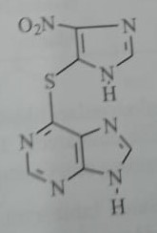
Cyclosporin (Cyclosporin-A)
This is a cyclic homodet-undekapeptide with hydrophobic properties. It consists of eleven amino acids. It was first isolated from incomplete fungi (Polypocladium inflatum and Cylindrocarpon lucidatum Booth) in 1970. When looking at the primary and tertiary structure, the amino acid in the first position is outside the tertiary structure. All configurations of amino acids are shown in the table. It was determined that the 1st, 2nd, 3rd and 11th amino acids in the amino acid chain of the oligopeptide play the role of a pharmacophore in immunosuppressive activity. However, as a result of some changes in the amino acid in the 2nd position, the hydrophobic bond formed by the drug with the cyclosporine receptor is strengthened. Seven of the 11 amino acids in the molecule have an N-methyl subunit. This increases the lipophilicity of the peptide. The remaining 4 nitrogen atoms form the tertiary structure of cyclosporine due to hydrogen bonds. Since the amino acid in the third position is N-methylglycine, it is not chiral. Alanine in the eighth position is in the R-configuration, and the rest of the amino acids are in the S-configuration.
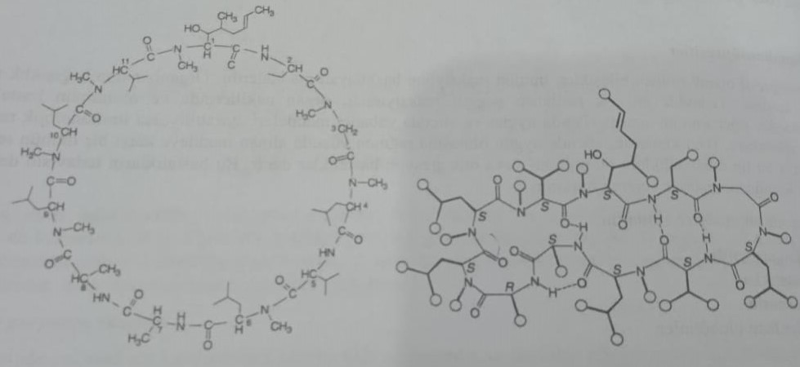
Cyclosporine inhibits both humoral and cellular immune responses. It inhibits the expression of both IL-1 from monocytes and IL-2 from T-lymphocytes. A decrease in the synthesis of IL-1 and IL-2 leads to a decrease in the generation of cytostatic T cells from T cells.
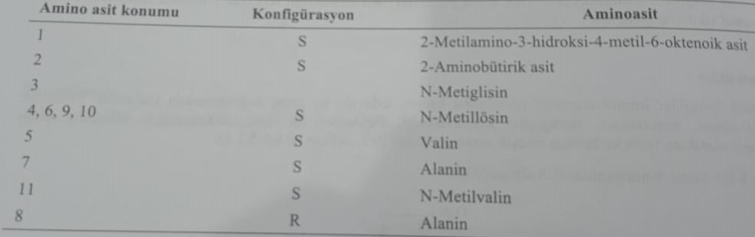
The mechanism of action is connected with the inhibition of cis-trans-isomerization of pyrroline. This transformation is explained by the prevention of the formation of a mixed structure of a three-dimensional protein. Cyclosporine binds to intracellular cyclophilin, which is similar to pyrrolinisomerase, and inhibits isomerase. In fact, cyclosporine does not affect the ability of cells to phagocytose. Therefore, it does not have a negative effect on the bacterial resistance of the organism. After introducing ciclosporin to the clinic, improvement in organ transplantation was observed. Unlike other immunodepressants, myelotoxicity is very low. At the same time, it is widely used in bone marrow transplantation.
Absorption when taken inside is 35%. It is completely metabolized in the body. The elimination period is 24 hours. A serious side effect is renal failure, which develops in a dose-dependent manner. At the same time, liver function violation, cardiotoxicity, tremor, hirsutism, sky shift and edema are observed. It very rarely causes hyperemia and convulsions. The use of ciclosporin with nephrotoxic preparations is not allowed. When using cyclosporine together with azole antifungal drugs, it is recommended to reduce the dose of the drug, since the metabolism of cyclosporine in the liver is prevented.
Tacrolimus
This macrolide-lactone, registered in 2001, entered the clinic as an immunodepressant similar to ciclosporin. This compound, a 23-atom lactone, is called α,β-diketonamide, a masked semichelate. Streptomyces tsukubaenis was isolated from culture. It inhibits the humoral and cellular immune response. It shows this effect by forming a complex with immunophilin. Thus, this formed complex inhibits the calcium-dependent protein-phosphatase activity of the calneurin-calmodulin complex. Thus, it suppresses the activity of B-cells. At the same time, it causes a decrease in T-cells and the expression of the TNF-α gene.
Absorption when taken inside varies from 5 to 50% depending on the condition of the patient. It is used in a dose of 0.1-0.3 mg/kg.
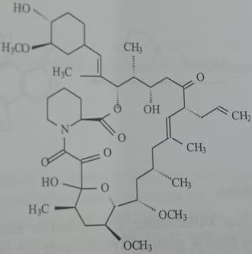
Sirolimus
It was isolated from the culture of Streptomyces hygroscopius under the name ropamycin. Binding to immunophiles, the complex (FKBP-12) blocks the calcineurin-calmodulin complex. Although it does not block the synthesis of IL-2, it inhibits the proliferation of T- and B-cells. This is a 33-atom macrolide lactone with a molecular structure similar to tacrolimus. FDA approved.
As a rule, cyclophosphamide, methotrexate and azathiopyrin are prescribed as antitumor drugs from immunosuppressive cytostatics. Mycophenolate mofetil is a compound used as a specific immunodepressant.
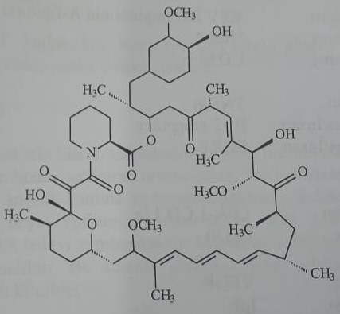
Mycophenolate mofetil: 2-morpholinoethyl (Е)-6-(4-hydroxy-6-methoxy-7-methyl-3-oxo-5-phthalanyl)-4-methyl-4-hexenoate.
This is a derivative of mycophenolic acid obtained by semi-synthesis. It is obtained by fermentation from Penicillium glaucum. Mycophenolic acid, an active metabolite, inhibits inosine monophosphate dehydrogenase. This enzyme is extremely important for de novo synthesis of purines. Tormozit formation of antibodies and proliferation of T- and B-lymphocytes. In combination with cyclosporine and glucocorticoids, it is used to prevent acute immune reactions that occur during transplantation of various organs. They are prescribed in a daily dose of 1-1.5 g. Side effects include fever, infection, edema, anemia, leukopenia, thrombocytopenia, and hypertension.
(Е)-6-(4-hydroxy-6-methoxy-7-methyl-3-oxo-5-phthalanyl)-4-methyl-4-hexane was subjected to interaction with thionyl chloride to form mycophenolic acid, purified after fermentation of Penicillium glaucum. Chlorine anhydride is obtained. Its esterification with N-(2-hydroxyethyl)morpholine gives mofetil mycophenolate.
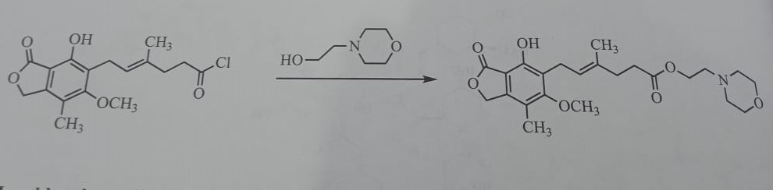
Monoclonal and polyclonal antibodies
Another method of immunosuppression is the use of antibodies. These antibodies are divided into 2 groups: monoclonal and polyclonal.
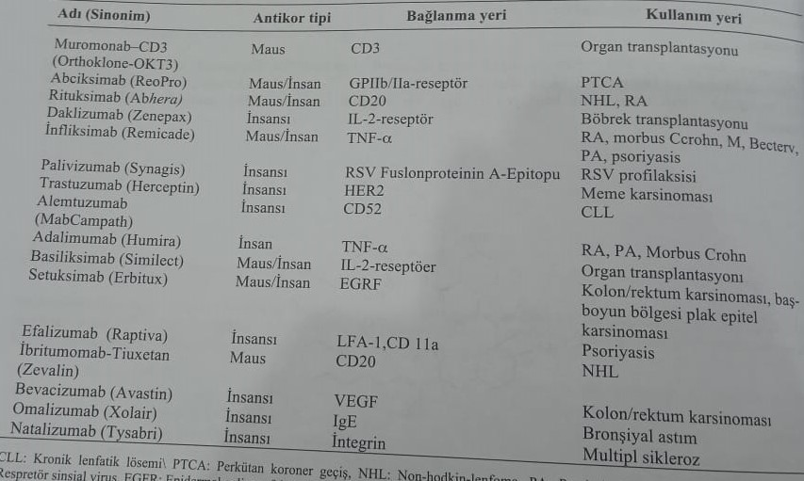
Their names differ by the last syllable.
1) Antibodies, cloned from mice, take the ending monab or omab. (eg: Muramonab)
2) An antibody cloned from a mouse/human accepts a ximab endpoint (for example, basiliximab).
3) Klonirovano iz čelveko - prámejte okonchanie zumbab. (eg, daclizumab)
4) Completely cloned from a well-known person - takes the ending of mumab.
These antibodies are used in the treatment of organ transplants and various autoimmune diseases. Indications are indicated below:
1) Chronic glomerulonephritis with nephrotic syndrome
2) Chronic inflammation of the colon
3) Myasthenia gravis
4) Autoimmune hepatitis
5) Rheumatoid arthritis (rheumatoid arthritis)
6) thrombopenic purpura

Antilymphocyte globulin
Monoclonal antibodies (Muranob-CD3) and polyvalent antilymphocyte plasma are used as an immunosuppressant in the clinic. Muranob-CD3 is a monoclonal antibody induced against CD3 T-lymphocyte protein in rats. It prevents the formation of a lymphocyte-receptor connection, which will be formed with the antigen. It is used when transplanting organs.
Plasma (serum), obtained as a result of immunization of experimental animals with diseased lymphocytes, is called antilymphocyte serum. Antibodies against the surface proteins of lymphocytes are formed. Lymphopenia is observed as a side effect after injection.
Treatment of multiple sclerosis (MS)
RS is an autoimmune disease. The exact pathogenesis is unknown. Cells of the immune system damage nerve, brain and spinal myelin cells. It manifests itself in patients with rapid fatigue. Rapid fatigue with tingling and spastic twitching is observed. T-lymphocytes activated as a result of the disease overcome the blood-brain barrier and cause inflammation of the brain. It is still not possible to completely cure the disease. Primarily symptomatic treatment. For this purpose, glucocorticoids, interferon, azothiopyrin and methotrexate are used. The following are used in the clinic for the treatment of RS:
1) Glatiramer acetate
2) Natalizumab (monoclonal antibody)
Glatiramer Acetate
This is an immunomodulator with a mixture of 4 important amino acids, which are part of myelin. This mixture of proteins is a polymer similar to myelin. It is used in the treatment of multiple sclerosis. Improves neurological function. It is applied subcutaneously in a daily dose of 20 mg. The effect appears after a three-month course of treatment. A side effect is an allergic reaction in the post-injection area.
Natalizumab
It has an inhibitory effect on the α-4 integrin adhesion molecule in immune cells. Reduces inflammation of the brain, avoiding GEB. Due to the large number of side effects, it should be used under the supervision of a doctor. The drug is used for resistance to β-interferon. The calculated half-life period is 16 days. It is used as an infusion at a dose of 300 mg every four weeks. Duration of treatment is 2 years. Side effects include urinary tract infection, nasopharyngitis, urticaria, headache, dizziness, fever, arthralgia, and individual sensitivity. Leukoencephalopathy is especially observed.

